Supplementary Material
We previously described the construction of a ura3 deletion in C. parapsilosis and here we used a similar approach to generate a his1Δ/ura3Δ strain. HIS1 was disrupted using the SAT1-flipper cassette . Due to the low efficiency of integration at HIS1, the two alleles were disrupted using different constructs (pCD35 and pCD37). For plasmid pCD35, a 405-bp fragment from the upstream region of HIS1 (including 354 bp of promoter sequence and 51 bp coding sequence) was amplified using oligonucleotides BUT316 and BUT317, introducing restriction sites KpnI and ApaI respectively, which was then cloned into plasmid pCD8 , generating pCD33. A 423-bp fragment from the downstream region of HIS1 was amplified using oligonucleotides BUT318 and BUT319, and was cloned between restriction sites SacII and SacI on plasmid pCD33 to generate pCD35. The SAT1 cassette was isolated from plasmid pCD35 by digestion with KpnI and SacI, and the fragment was introduced into ura3 deletion strain CDU1 to delete the first HIS1 allele. The SAT1 cassette was then recycled from CDUhis1, generating the heterozygote knockout CDUhis11. For plasmid pCD37, a 439-bp fragment from the upstream region of HIS1 (including 110 bp of promoter sequence and 329 bp of coding sequence) was amplified from C. parapsilosis genomic DNA using oligonucleotides HisKpn2 and HisApa2, and the fragment was cloned between restriction sites KpnI and ApaI in plasmid pCD35 to generate plasmid pCD37. The cassette was released from pCD37 by digestion with KpnI and SacI, and the purified fragment was introduced into CDUhis11 to generate strain CDUH1. Recycling of the cassette from CDUH1 generated CDUH3.

Verification of gene disruption by PCR and Southern blot analysis
Southern blots were used to confirm the his1 deletion. 20 μg of genomic DNA from the wildtype and HIS1 knockout strains (CLIB214, CDUhis1, CDUhis11, CDUH1, and CDUH3) were digested with HincII. A probe was amplified from C. parapsilosis genomic DNA using BUT318 and BUT319, which binds to a region of HIS1 downstream from the integration site. Labeling and hybridizations were carried out using a DIG High Prime DNA Labeling and Detection Starter Kit II (Roche).
The BCR1 knockout generated using URA3 and HIS1 was confirmed by PCR. Oligonucleotides BUT261 binds upstream from BCR1 and URAR binds within the URA3 cassette, generating a fragment of 1.25 kb. Oligonucleotides BUT261 and HISR, which bind within HIS1, generate a fragment of 1.25 kb. Oligonucleotide BUT261 and BUT262 (from within the BCR1 ORF) were used to confirm the deletion of both alleles.

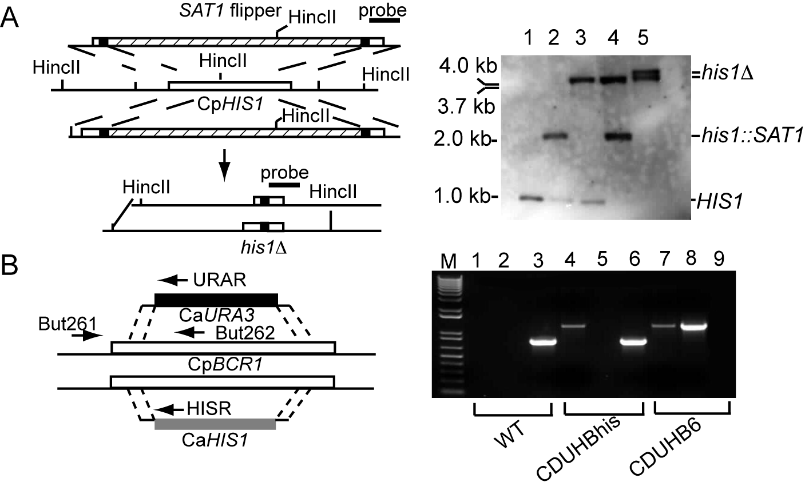

Figure S1. Deleting HIS1 and BCR1 in C. parapsilosis.
- HIS1 was knocked out in a ura3 null strain of C. parapsilosis (CDU1 ) using the SAT1-flipper cassette, to generate a ura3Δhis1Δ strain (CDUH3).Two different constructs were used to disrupt the two HIS1 alleles, as described in Methods. Genomic DNA was isolated from five strains, digested with HincII and hybridized with a probe from the downstream region from HIS1. The wildtype allele generates a1.0 kb fragment. Integration of the cassettes at HIS1 produces a 2.0 kb fragment. Recycling of the first cassette generates a 3.7 kb fragment, and recycling of the second cassette results a 4.0 kb fragment. Lane 1: C. parapsilosis CLIB214; Lane 2: C. parapsilosis CDUhis1 (his1Δ::SAT1-FLP/ HIS1); Lane 3: C. parapsilosis CDUhis11 (his1Δ::FRT/ HIS1); Lane 4: C. parapsilosis CDUH1 (his1Δ::FRT/ his1Δ::SAT1-FLP); and Lane 5: C. parapsilosis CDUH3 (his1Δ::FRT/ his1Δ::FRT). All strains (apart from CLIB214) are also carrying ura3 deletions.
- BCR1 was disrupted by replacement with URA3 and HIS1 genes from C. albicans, amplified by PCR and transformed into C. parapsilosis CDUH3 by electroporation. Integration of the HIS3 gene was confirmed by PCR using oligonuleotides But261 and HISR that generates a 1.26 kb fragment which is absent in the wild-type strain. Integration of URA3 was confirmed using oligonuleotides But261 and URAR, which generates a 1.25 kb fragment. The deletion of BCR1 was confirmed using oligonucleotides But261 and But262, which generate a 0.8 kb fragment from the wildtype allele. Lanes 1,4,7: But261/HISR; Lanes 2,5,8: But261/URAR; Lanes 3,6, 9: But261/But262. WT = CDUH3, CDUHBhis (bcrΔ1::HIS1/BCR1), CDUHB6 (bcrΔ1::HIS1/ bcrΔ1::URA3).

Ding, C. & G. Butler, (2007) Development of a gene knockout system in Candida parapsilosis reveals a conserved role for BCR1 in biofilm formation. Eukaryot Cell 6: 1310-1319.

