Supplementary Fig.1: Oxygen consumption in C. glabrata clinical isolates and in mitochondrial mutants. The respiratory activity of C. glabrata was determined by oxygraphy using stationary growth-phase blastoconidia (16 h at 34°C) from YEPD cultures. After washing in sterile distilled water, cells (1.7 x 106/ml) were suspended in 10 mM potassium phosphate buffer pH 7.4, containing 20 mM glucose. Oxygen consumption was measured at 37°C with a Clark electrode (Micro Oxygen Probe, YSI, Yellow Springs, OH) on 106 cells. Respiration activities were recorded with an air-calibrated 5300A Biological Monitor (YSI) and are expressed as percentage of oxygen consumed per minute.
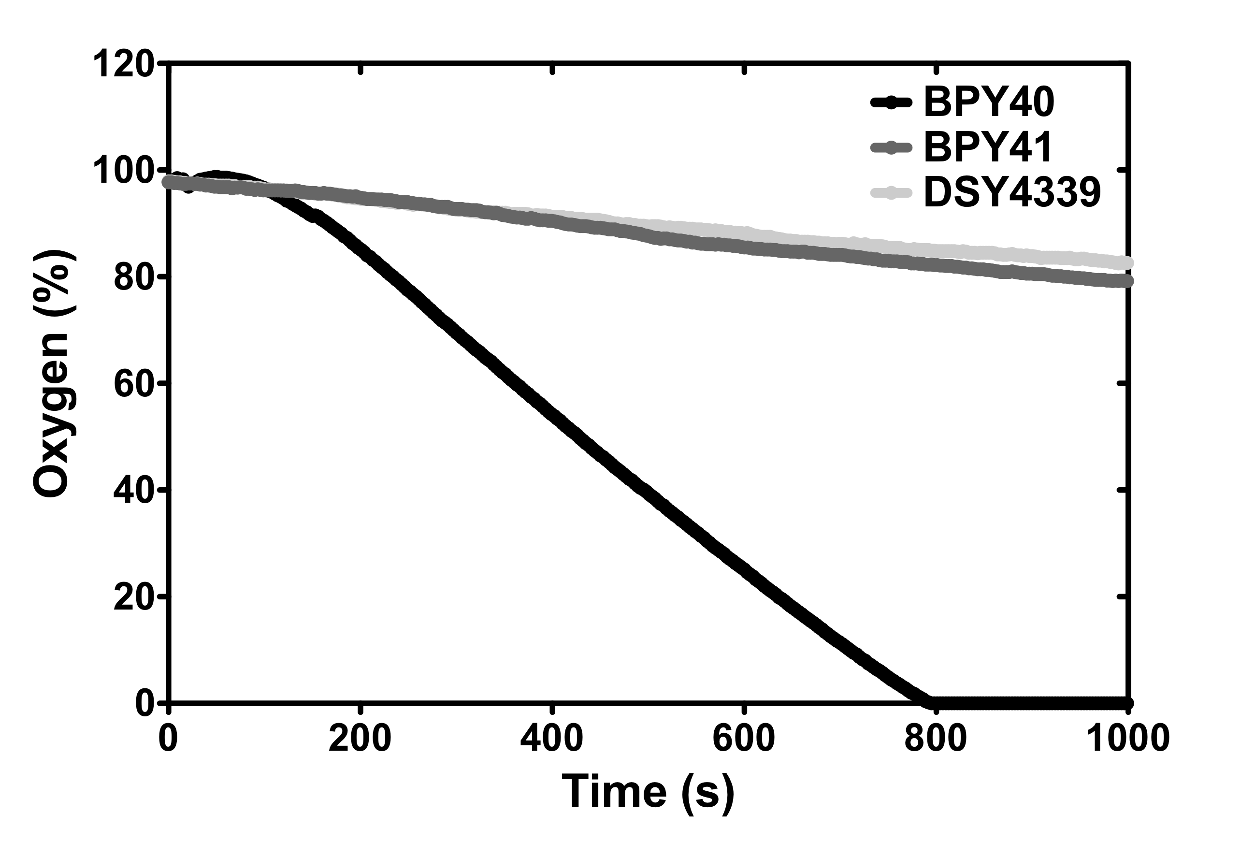

Supplementary Fig.2: Isolation of mitochondrial DNA from C. glabrata strains BPY40 (respiratory competent), BPY41 and DSY4339 (mitochondrial mutants). Mitochondrial DNA was isolated following the procedure published by Defontaine et al. . Mitochondrial DNA was digested with EcoRV which resulted in the separation of two fragments after agarose gel electrophoresis and ethidium bromide staining under UV-light. No mitochondrial DNA was recovered from BPY41 and DSY4339, suggesting that these two isolates are Rho⁰.
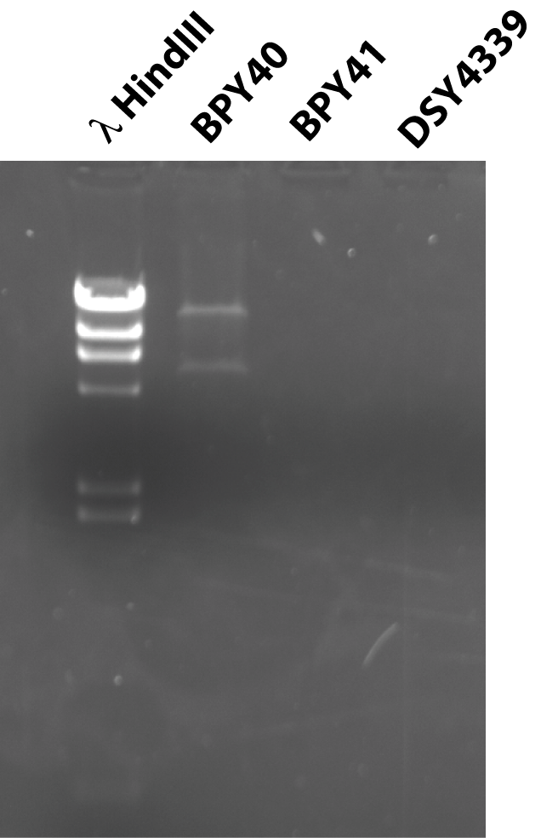

1. Defontaine, A., F. M. Lecocq, and J. N. Hallet. 1991. A rapid miniprep method for the preparation of yeast mitochondrial DNA. Nucleic Acids Res 19:185.

Supplementary Fig. 3: RSAT analysis of consensus sequence in the promoters of genes upregulated in BPY41

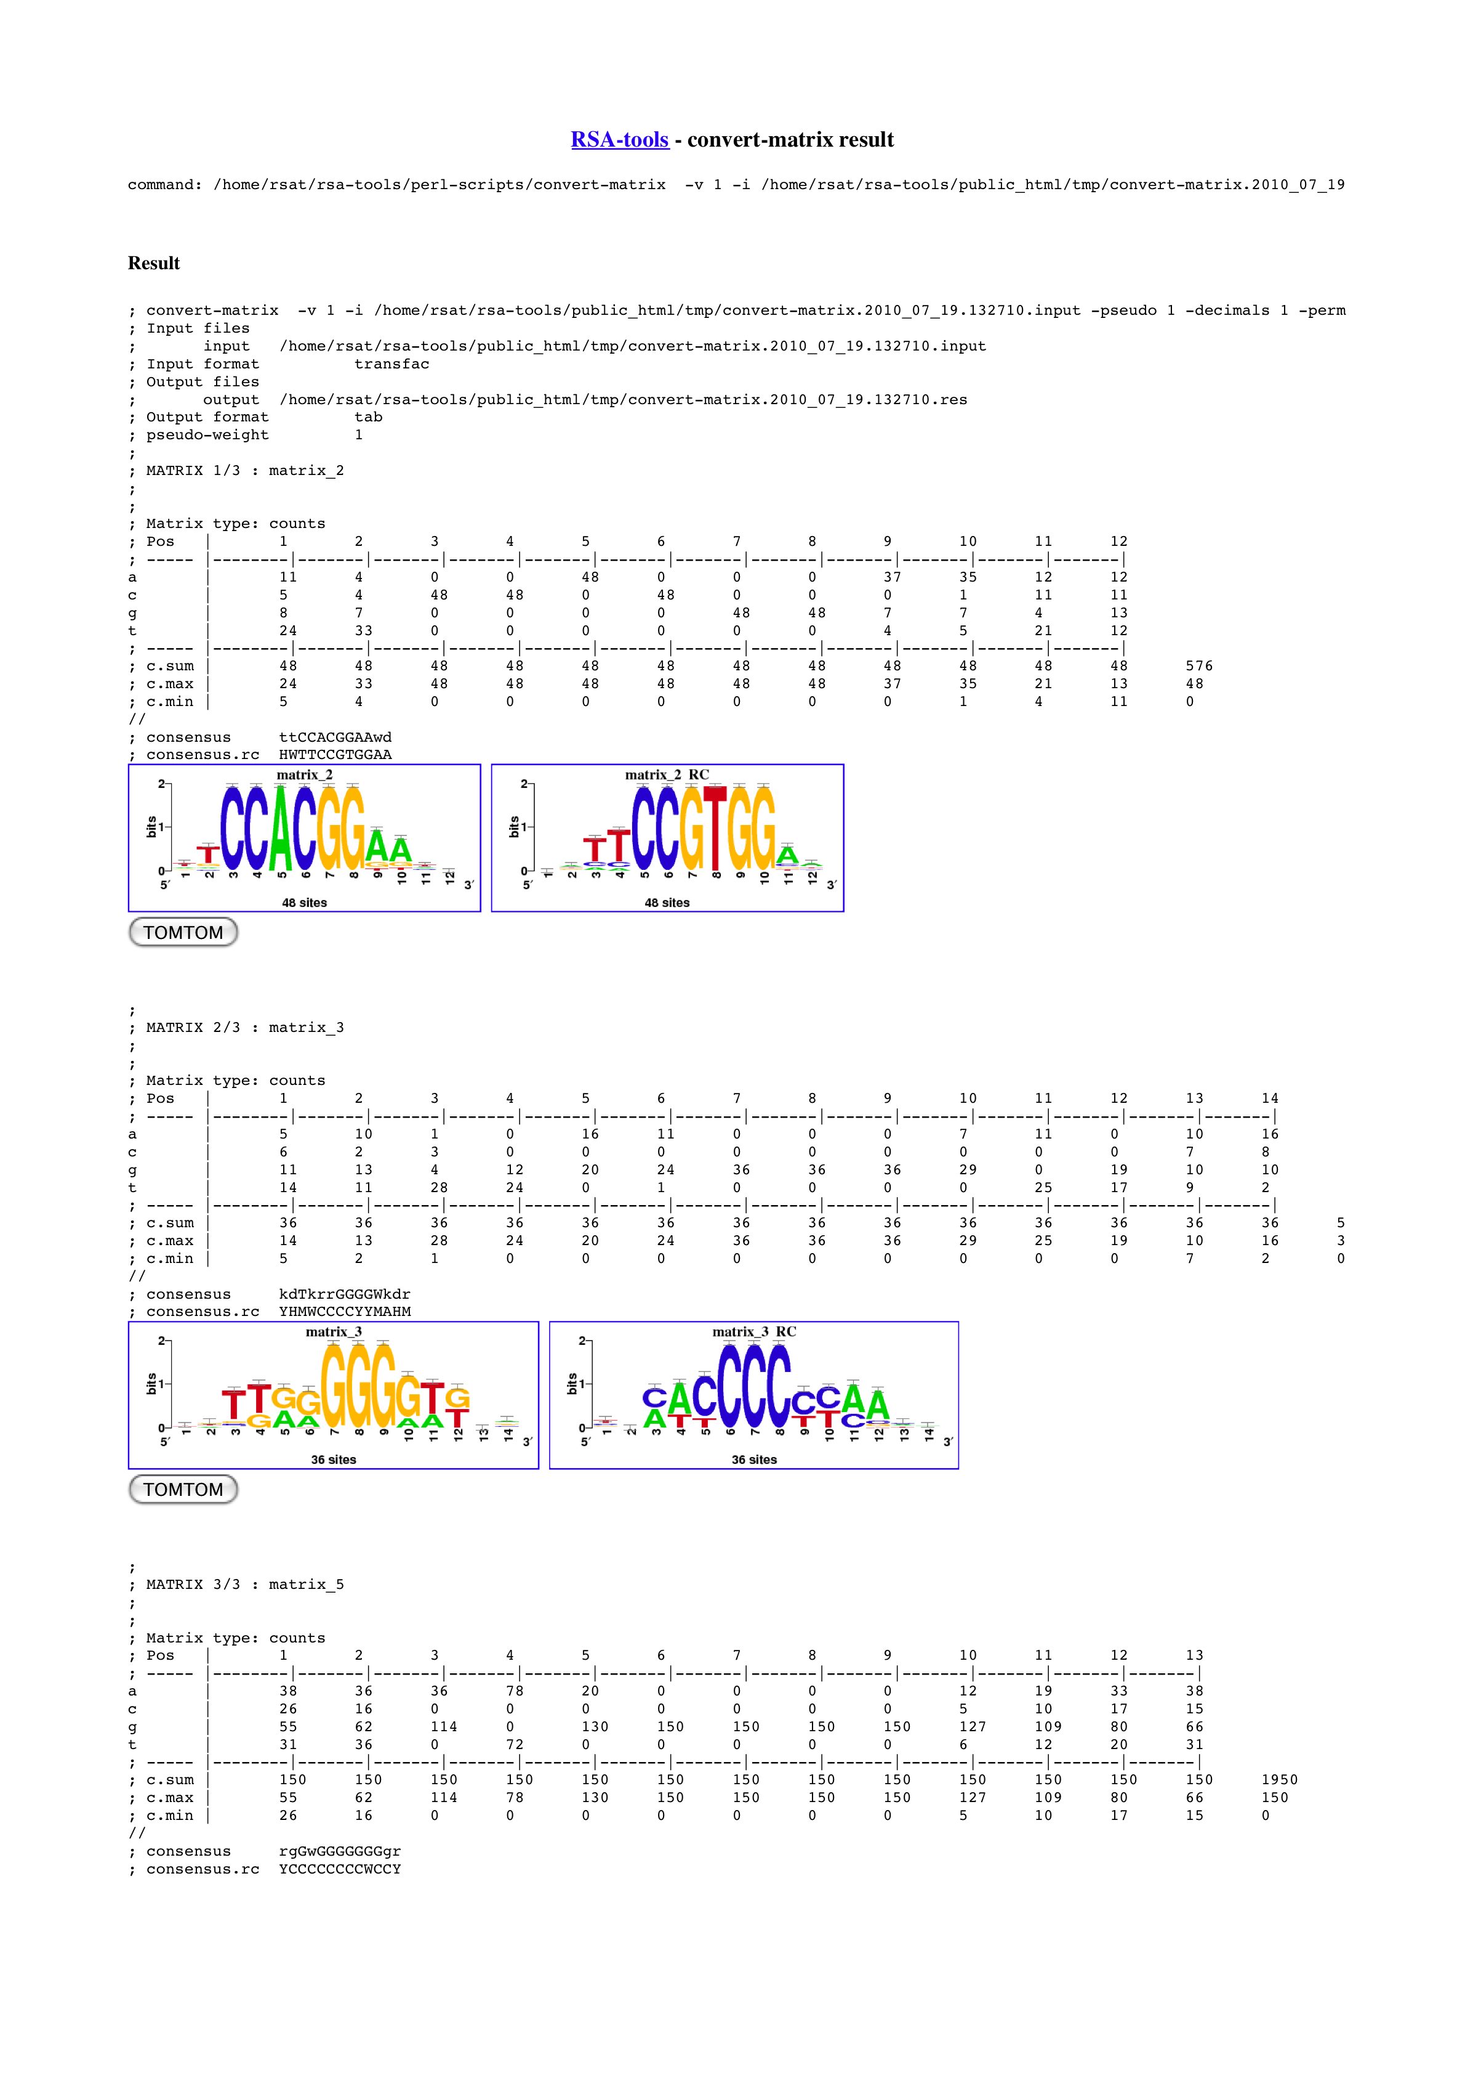
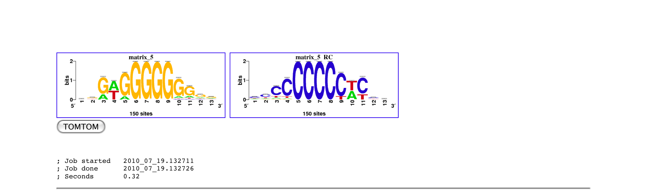
Supplementary Fig. 4: Growth curves of C. glabrata clinical strains and mitochondrial mutants. Isolates were cultured in triplicates in YEPD medium at 30°C and absorbance recorded at given time points.

