Supplemental Table 7: Correlation of replicate microarrays for each time point.

Time point | Correlation (%)
exponential | 91.2
3d | 99.5
5d | 100
7d | 95.6
11d | 90

Exponential 3d
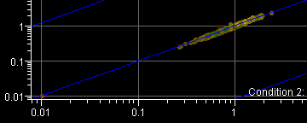
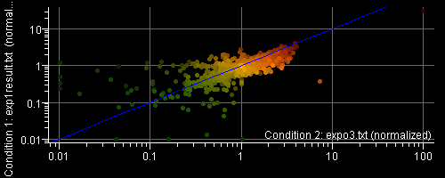

5d 7d
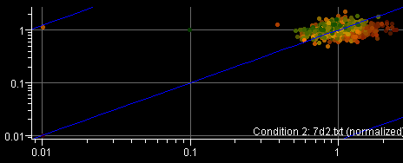

11d
